

**JS TECH ACADEMY**

VILLAGE SAURA, POST JALALPUR KASBA, PRAYAGRAJ 212402

**Admission Form**

**BASIC COURSE ON COMPUTER SKILLS (BCCS)**

Form No:

|  |  |
| --- | --- |
| **FOR OFFICE USE ONLY** | Affix your recent Passport size Photograph here |
| **Registration No: Batch: Course: Date of Admission:** |

**Course Code**:  **USE ONLY BLOCK LETTERS**

**Name of the Applicant:**

**Father’s Name** : **Mother’s Name:-**

**Address** :

**Post Office**:

**District** : **Pin Code** :

**Phone (Resident)** : **Mobile** :

**Date of Birth** : **Do you have any previous computer Knowledge**: : YES  NO 

**If you have any computer exposure, furnish details** :

**Educational Qualification:**

|  |  |  |  |  |
| --- | --- | --- | --- | --- |
| **Sl. No** | **EXAM PASSED** | **YEAR** | **BOARD/ UNIVERSITY** | **% of MARKS OBTAINED** |
|  |  |  |  |  |
|  |  |  |  |  |
|  |  |  |  |  |
|  |  |  |  |  |
|  |  |  |  |  |

I do hereby declare that the particulars furnished above are true to the best of my knowledge. I declare that I will abide by the rules of Don Bosco College, Tura.

Date

Father’s/Guardian’s Signature

Applicant’s Signature

Place

*************************************************** Cut here ******************************************************

Form No:

Date :

Name of the Applicant : Address :

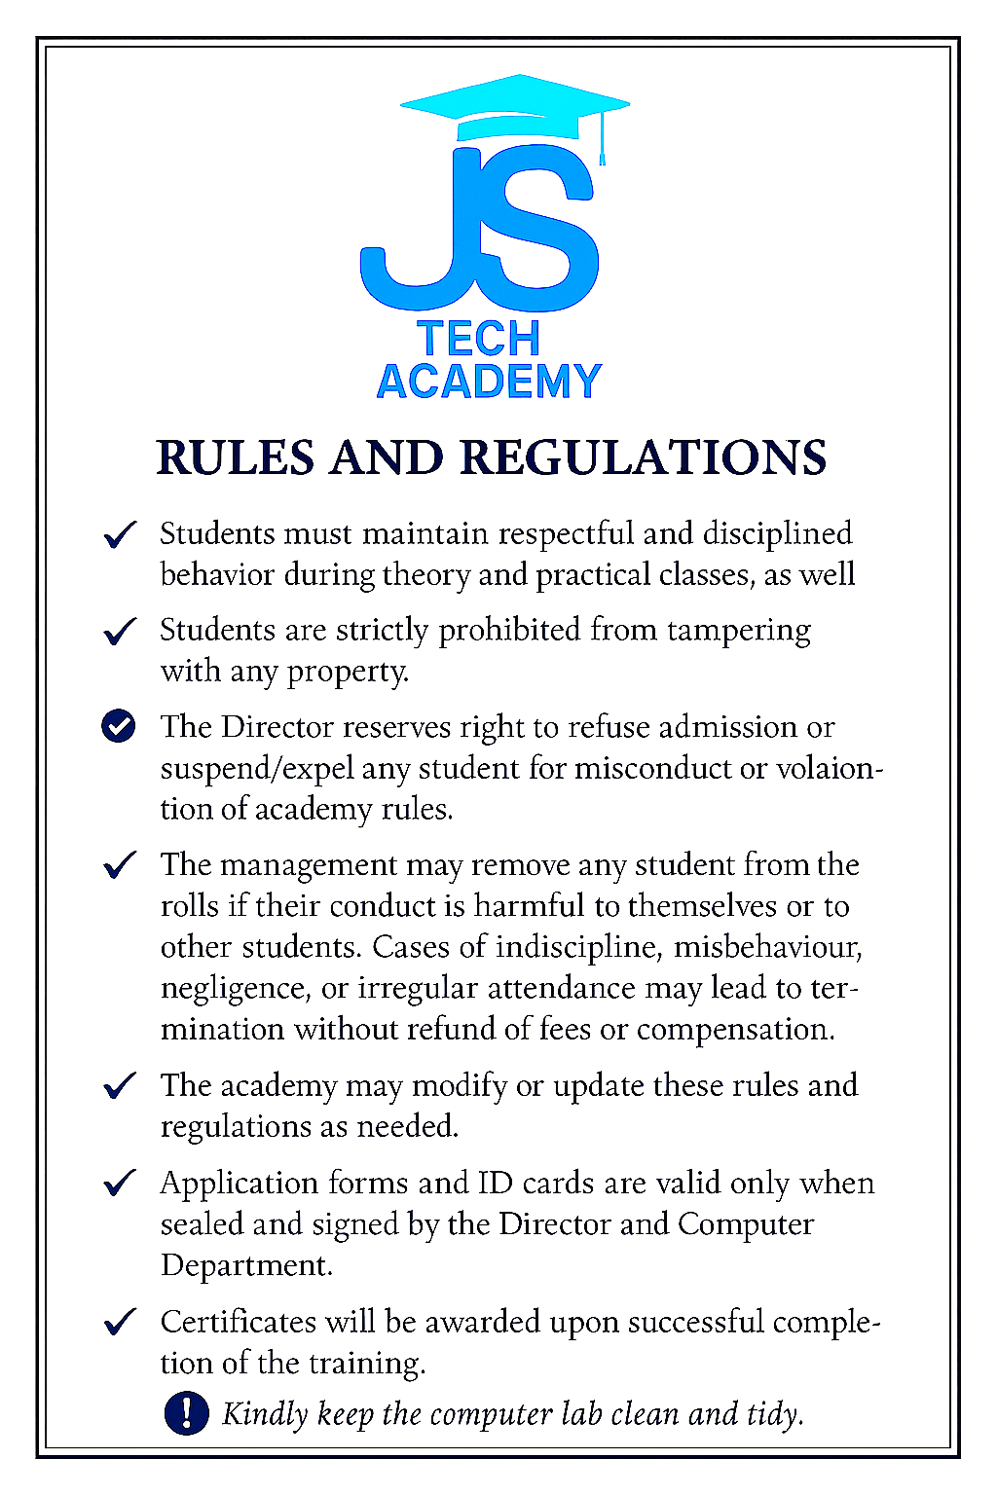

**Signature of the Director Date**